1. **Create on Bash script to check if a directory is available or not**

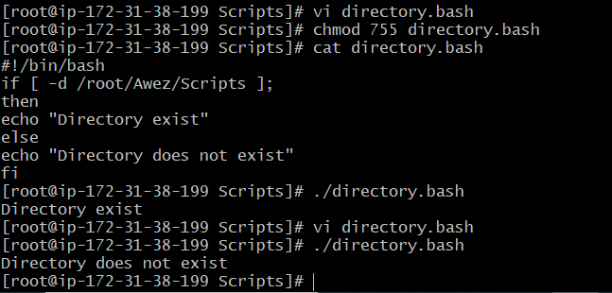

1. **Create a bash script which will create multiple files.**

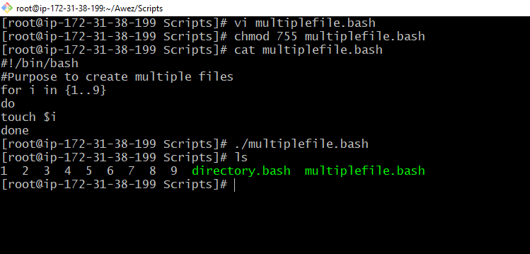

1. **Create a bash script to take backup of a directory.**

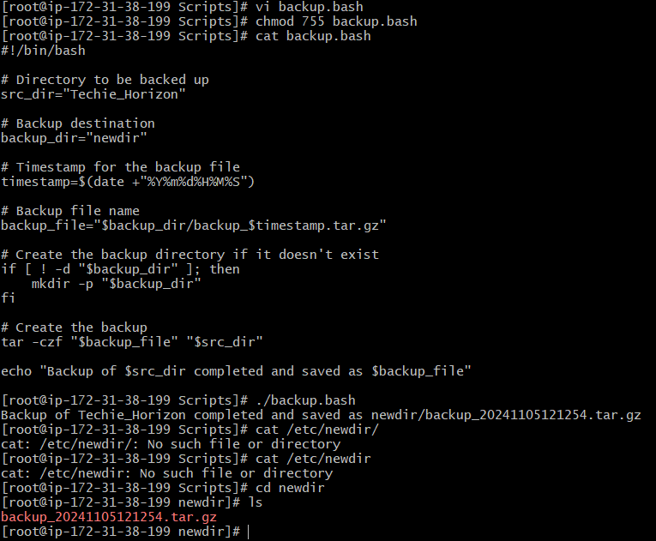

1. **Create a bash script to install nginx in ec2 server.**

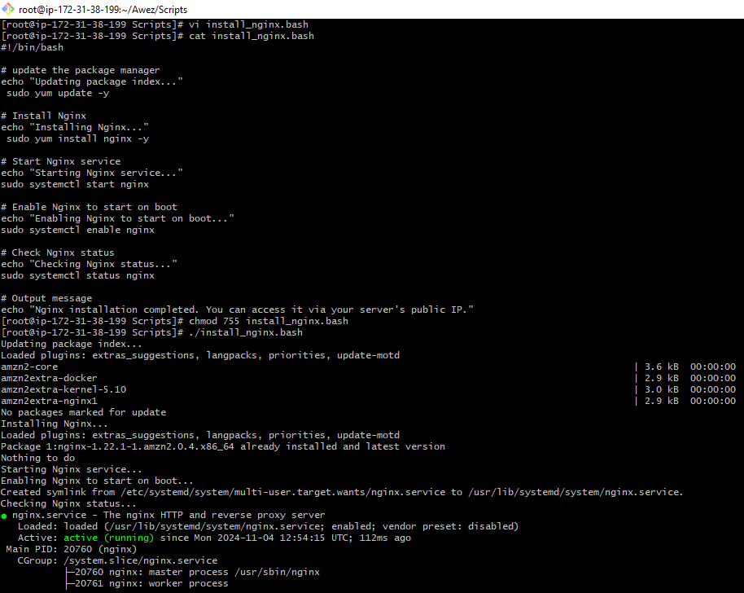

1. **Create a bash script to install ApacheTomcat in ec2 server.**

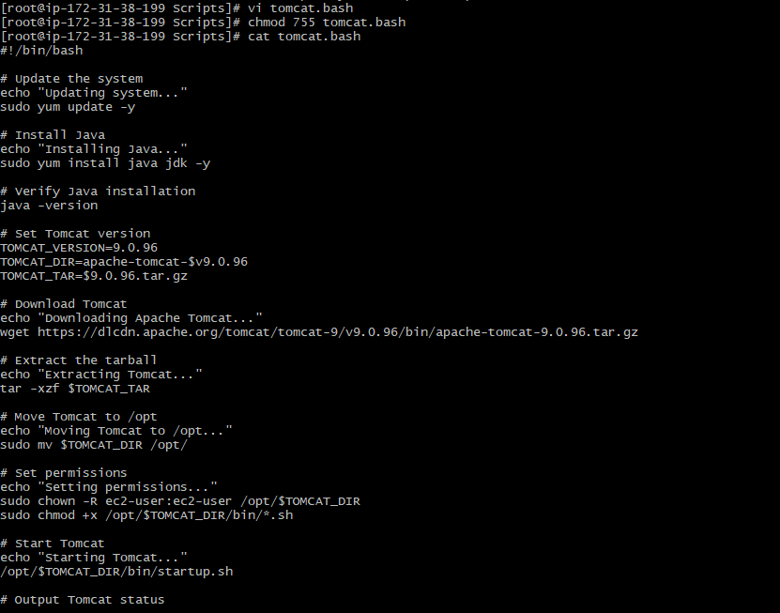

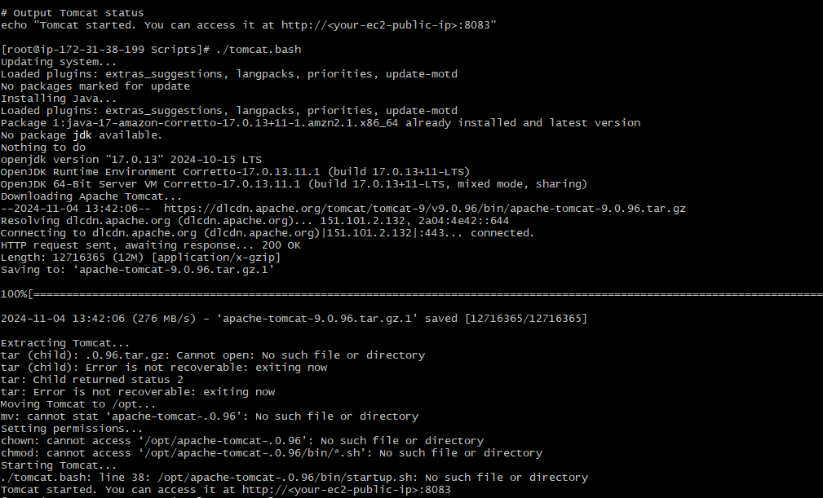

1. **Create a bash script to check list if nginx service is running or not,if not running then script should start the service.**

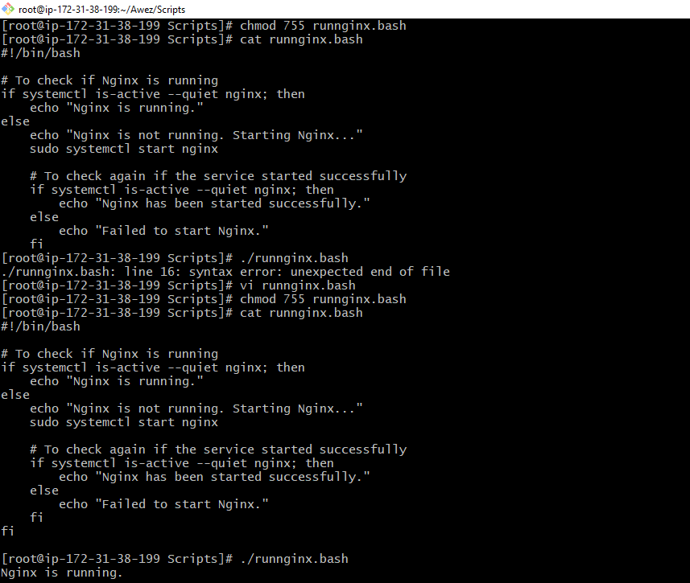

**7) Create a bash script for calculator.**

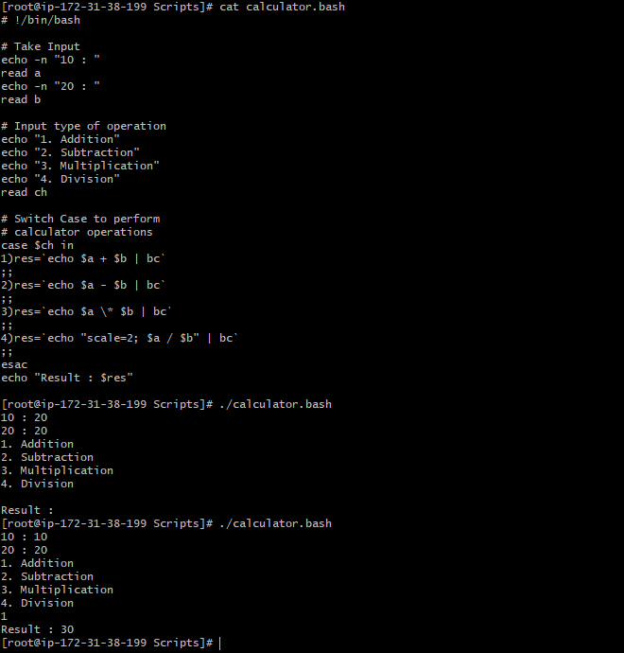

**8)** **Create a bash script to check if directory is avaialble or not,if not then create a directory.**

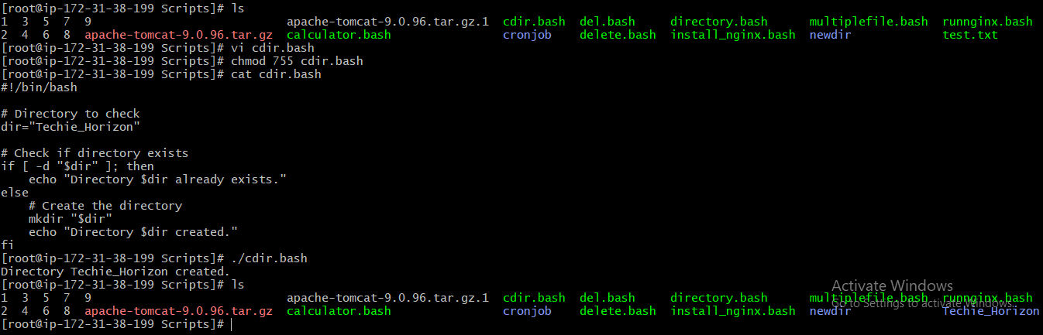

**9) Create bash script to delete last 3 lines for a file.**

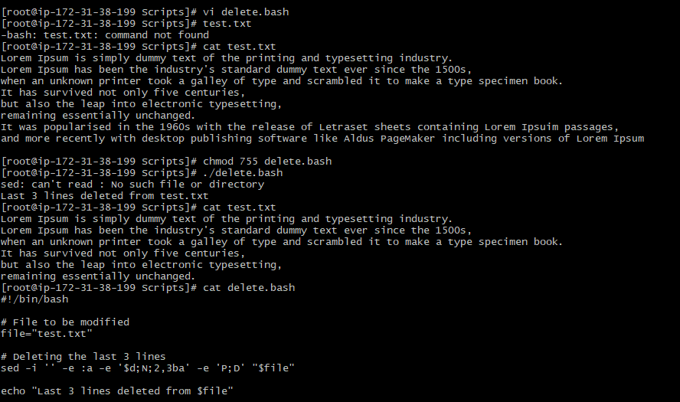

**Crontab**

**1) April 5th Midnight**

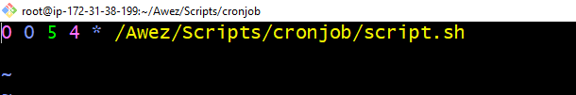

**2) 5 th of Every November,Jan,June if it is a Thursday.**

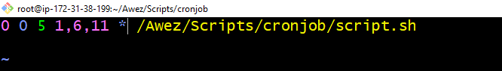

**3) At 05 and 27th minutes of 9,10,11 hours everyday.**

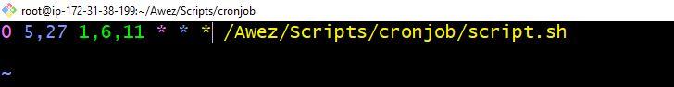

**4) 34 min. of 9th hour on 15th Aug.**



**5) Every midnight**

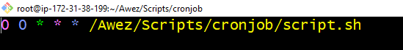

**6)Every Weekend ( Saturday night 11.59 )**

**7) After every reboot**

